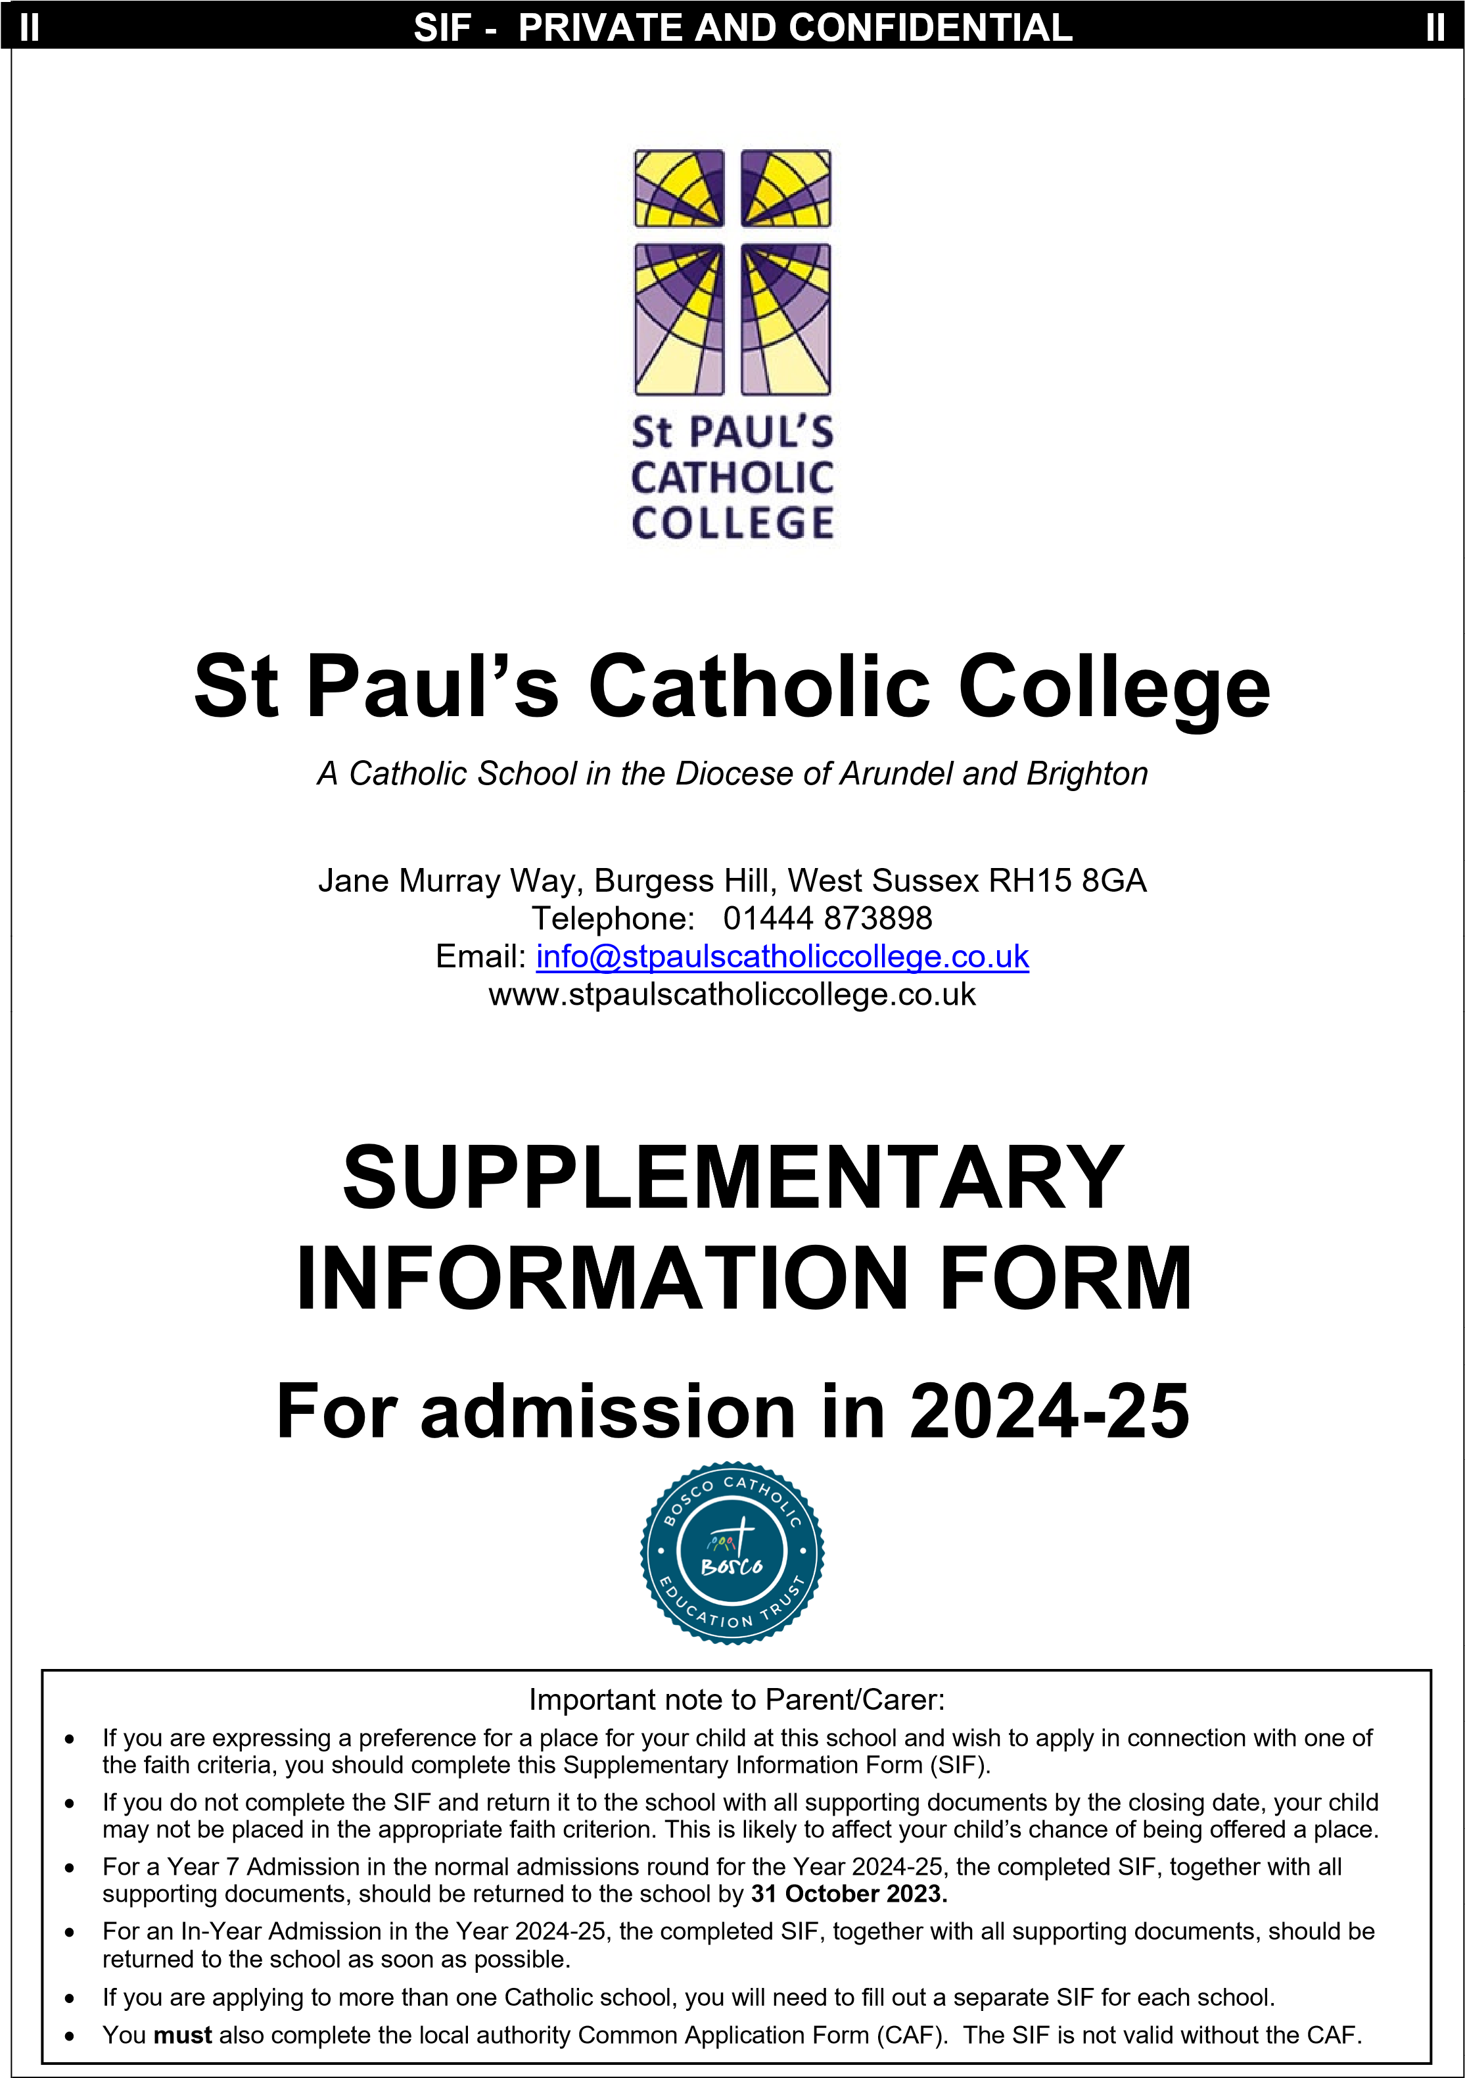

PLEASE COMPLETE ALL SECTIONS IN BLOCK CAPITALS

Student Details
Surname
Forenames (in full)
/ /
Date of birth:

Name of named feeder school
Does the child attend a named feeder school? (
see
note k.
of the Admissions Policy
)

Yes
No

Child’s Home
Address

 | Post Code:
Is the child resident in St Paul’s Catchment Area? Yes  (i.e. within the parishes of Burgess Hill & Keymer, Haywards Heath, Lewes, Uckfield with  Herons Ghyll, Newhaven & Peacehaven, Seaford, Henfield, Billingshurst with West Grinstead) |  |  |  |  | No
(See www.abdiocese.org.uk/education/find-a-school for zoomable maps)
Home Telephone Number
Proposed Date of Admission

Parent/Carer details
Name (in full)
Address
(
if different
from student
)

Contact telephone
number(s)

Email
Address
Brothers/Sisters: When completing the Local Authority’s Common Application Form (CAF), it is important that you provide details of any brothers and sisters who will be attending this school at the proposed time of admission. If this information is not provided on the CAF, the governors may not be able to place the application within the correct criteria. As a ‘back-up mechanism’, if you would also like to confirm to governors here (NB this is optional), that there will be a brother/sister at the school at the time of admission, please list below the Name(s)/Year Group(s) of the brother(s) &/or sister(s):

Name of student: _______________________________ Year Group: _____________

Name of student: _______________________________ Year Group _____________

Name of student: _______________________________ Year Group ______________

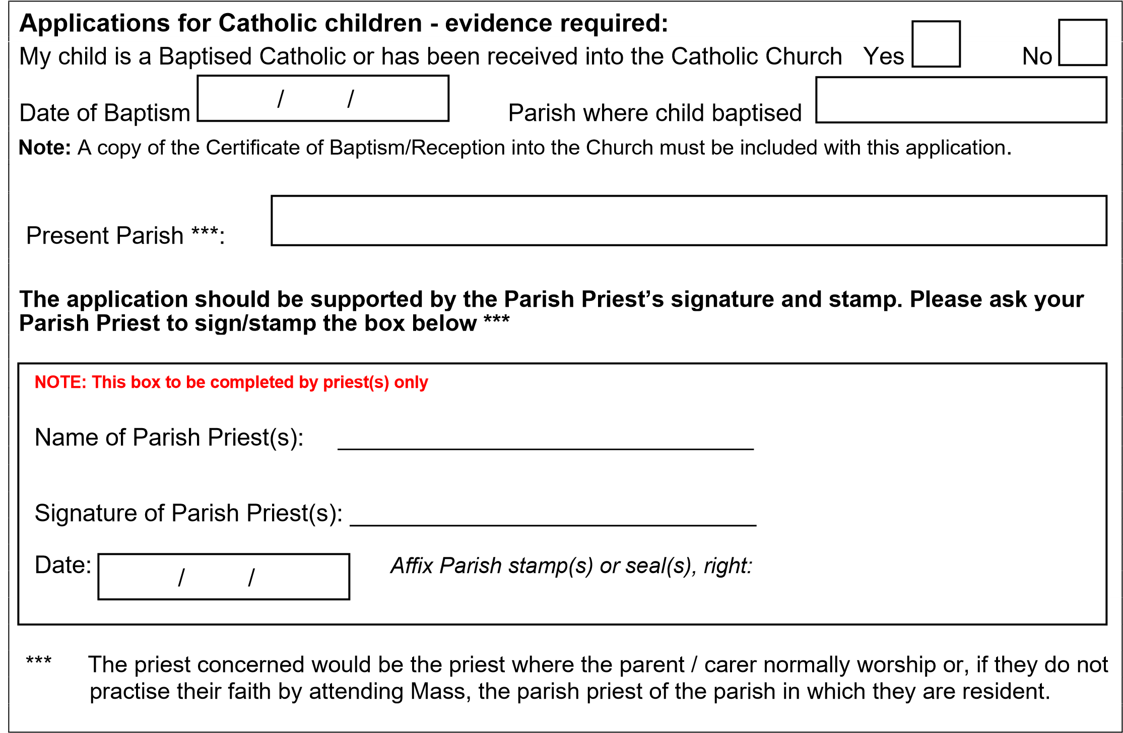

Applications from Catechumens or Candidates for Reception - evidence required:
If application is being made for a place at the school where the parent/carer is a Catechumen or a Candi date for reception into the Catholic Church, evidence of their being a member of the catechumenate of a Catholic Church or a candidate for reception will be required. Proof of acceptance into the catechumenate, and evidence for a candidate, should be by a confirmatory letter from the appropriate priest. This evidence should be provided at the same time as this form is returned to the school.

Applications for children who are members of an Orthodox Church - evidence required:
If application is being made for a place at the school where the child is a member of an Orthodox Church, evidence of membership will be required. Membership is normally evidenced by a certificate of baptism/ reception into the Orthodox Church. If that is not available, then a letter confirming membership of the applicable Orthodox Church, signed by the appropriate priest, will be required. The certificate of baptism/ reception from the authorities of that Church or the letter from the priest confirming membership should be provided at the same time as this form is returned to the school.

Applications for children of other Christian denominations - evidence required:

If application is being made for a place at the school where the child is a member of another Christian de-

nomination, either a certificate of baptism (where applicable) or a letter confirming membership of that

Christian denomination, and signed by the appropriate minister of religion, will be required. The certificate of baptism or the confirmatory letter from the minister should be provided at the same time as this form is
returned to the school.

Applications for children with Exceptional and Compelling Needs – evidence required:
Parents/carers wishing to have an Exceptional and Compelling Need considered with their application (criterion 2 or criterion 9) must submit independent professional evidence which explains clearly why it is essential to attend St Paul’s Catholic College. The supporting evidence from the qualified professional must detail fully the child’s needs and address the reason why these needs can only be met at St Paul’s Catholic College. (The evidence should be addressed to the Chair of Governors and either posted to the school by recorded delivery or, alternatively, handed in to the school office and a receipt received. For an entry into Year 7 in September 2024, the evidence should be received by the closing date for applications of 31 October 2023. Please refer to note l. of the admissions policy.

Application Declaration (to be signed by parent/carer)
Please note, for a valid application, the Common Application Form (CAF) must be returned either online or in paper form to the appropriate Local Authority.

I have completed and returned (either online or by post) the Local
Authority Common Application Form (CAF) to the Local Authority Yes No showing St Paul’s Catholic College as one of my preferred schools.

I confirm that I have read and understood the Admissions Policy and that the information I have given on this form is accurate and truthful. I understand that I must notify the school immediately if there is a change to these details and that should any information I have given prove false, the Governors may withdraw any offer of a place, even if the child has already started at the school.
(An example of false information would be the use of an address that is not the child’s normal residence).

Signed: | Parent/Carer Signature: ___________________________
 | Print full name Mr/Mrs/Miss/Ms/Dr: ___________________________
Date:

IMPORTANT CHECKLIST:
- I have fully completed this Supplementary Information Form
- My parish priest has signed/dated the correct section of the form (for Catholic applicants)
- I have enclosed, where applicable, a copy of:
- Certificate of Baptism in a Catholic Church (for Catholic applicants) or
- Certificate of Reception into Full Communion with the Catholic Church (for Catholic applicants)
- Confirmatory letter from the priest (for applications from Catechumens)
- Confirmatory letter from the priest (for applications from Candidates for Reception)
- Certificate of Baptism/Reception or letter from priest (for members of an Orthodox Church)
- Certificate of Baptism (where applicable) or letter from minister of religion confirming membership of other Christian denomination (for members of other Christian denominations)
- Letter from faith leader confirming membership of other faith (for members of other faiths)

Additional Note for Catholic applicants:
The School may request additional supporting evidence if the written documents that are provided do not clarify the fact that the child was baptised or received into the Catholic Church e.g. where the name and address of the church is not on the certificate or where the name of the church does not state whether it is a Catholic church or not. Those who have difficulty obtaining written evidence of baptism or reception into the Catholic Church should contact their parish priest.

When you have completed this form please return it (together with supporting documentation, if applicable) to: The Admissions Manager at St Paul’s Catholic College, Jane Murray Way, Burgess Hill, West Sussex RH15 8GA.

Reminder: The closing date for return of this form for a Year 7 place for September 2024 is: 31 October 2023.

Note: The school is committed to protecting the information provided by parents/carers and using it only for the purpose for which it was obtained. For information on the school’s Privacy Notice, please look on the school website or contact the school for a hard copy.

